 Facial Map

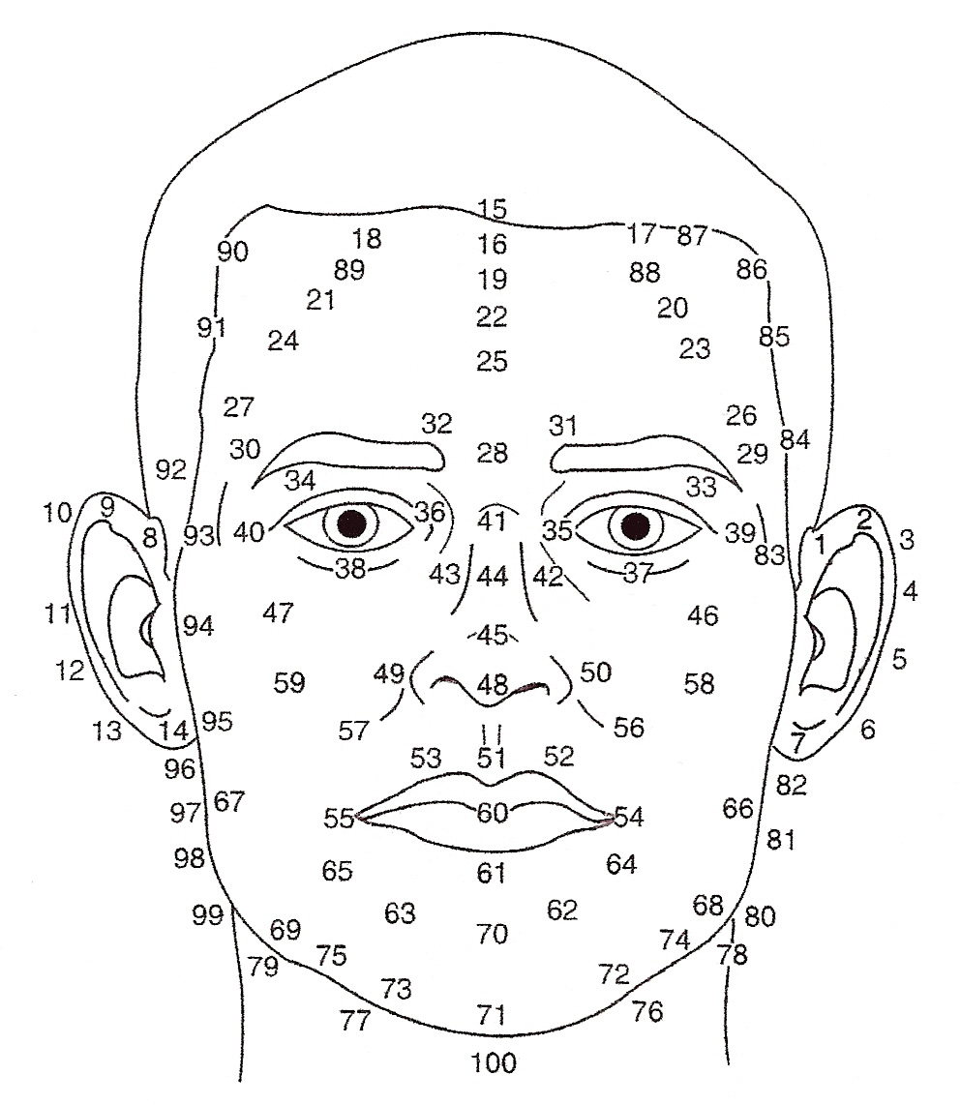

Numbers indicate Chinese age. Subtract 1 year for Western age.

©Lillian Bridges Lotus Institute Inc.

